**Dual Port RAM:**

It is a Random Access Memory which has 2 ports and can write the information on same time and read the information simultaneously.

**Verilog Code for Dual Port Ram:**

**`timescale 1ns / 1ps**

//////////////////////////////////////////////////////////////////////////////////

// Company:

// Engineer:

// Create Date: 04.10.2023 00:11:20

// Design Name:

// Module Name: dualportram

// Project Name:

// Target Devices:

// Tool Versions:

// Description:

// Dependencies:

// Revision:

// Revision 0.01 - File Created

// Additional Comments:

//////////////////////////////////////////////////////////////////////////////////

module Dualportram(input [7:0]a,

input [7:0]b,

input clk,

input [2:0] addrs_a,

input [2:0] addrs_b,

input wra,rda,wrb,rdb,

output [7:0] out_a,

output [7:0] out_b);

dualportram dualportram(.a(a),.wra(wra),.rda(rda),.out_a(out_a),.addrs_a(addrs_a),.b(b),.wrb(wrb),.rdb(rdb),.addrs_b(addrs_b),.clk(clk),.out_b(out_b));

endmodule

module dualportram(input [7:0]a,

input [7:0]b,

input clk,

input [2:0] addrs_a,

input [2:0] addrs_b,

input wra,rda,wrb,rdb,

output reg [7:0] out_a,

output reg [7:0] out_b);

reg [7:0] ram1[7:0];

reg [7:0] ram2[7:0];

always @(posedge clk)

begin

if(rda)

ram1[addrs_a]<= a;

if(wra)

out_a=ram1[addrs_a];

if(rdb)

ram2[addrs_b]<=b;

if(wrb)

out_b<=ram2[addrs_b];

end

endmodule

**Test Bench Code for Dual Port Ram:**

`timescale 1ns / 1ps

//////////////////////////////////////////////////////////////////////////////////

// Company:

// Engineer:

// Create Date: 03.10.2023 22:30:09

// Design Name:

// Module Name: singleportram_tb

// Project Name:

// Target Devices:

// Tool Versions:

// Description:

// Dependencies:

// Revision:

// Revision 0.01 - File Created

// Additional Comments:

//

//////////////////////////////////////////////////////////////////////////////////

module dualportram_tb;

reg clk;

reg [7:0] a;

reg [7:0] b;

reg [2:0]addrs_a;

reg [2:0]addrs_b;

reg wra,rda,wrb,rdb;

wire [7:0] out_a;

wire [7:0] out_b;

//Dut

dualportram dualportram(.a(a),.wra(wra),.rda(rda),.out_a(out_a),.addrs_a(addrs_a),.b(b),.wrb(wrb),.rdb(rdb),.addrs_b(addrs_b),.clk(clk),.out_b(out_b));

initial

begin

clk=1'b0;

forever #5 clk=~clk;

end

initial

begin

a=8'b00011000;

b=8'b00010100;

//read operation for a

#10 rda=1;

rdb=1;#10

//read operation for b

rda=1;

rdb=1;

//write operation for Port A

#10 wra=1'b1;addrs_a=3'b000;

#10 wra=1'b1;addrs_a=3'b001;

#10 wra=1'b1;addrs_a=3'b010;

#10 wra=1'b1;addrs_a=3'b011;

#10 wra=1'b1;addrs_a=3'b100;

#10 wra=1'b1;addrs_a=3'b101;

#10 wra=1'b1;addrs_a=3'b110;

#10 wra=1'b1;addrs_a=3'b111;

//write operation for Port B

#10 wrb=1'b1; addrs_b=3'b000;

#10 wrb=1'b1; addrs_b=3'b001;

#10 wrb=1'b1; addrs_b=3'b010;

#10 wrb=1'b1; addrs_b=3'b011;

#10 wrb=1'b1; addrs_b=3'b100;

#10 wrb=1'b1; addrs_b=3'b101;

#10 wrb=1'b1; addrs_b=3'b101;

#10 wrb=1'b1; addrs_b=3'b110;

#10 wrb=1'b1; addrs_b=3'b111;

#100 $finish;

end

endmodule

**Simulation Waveform:**

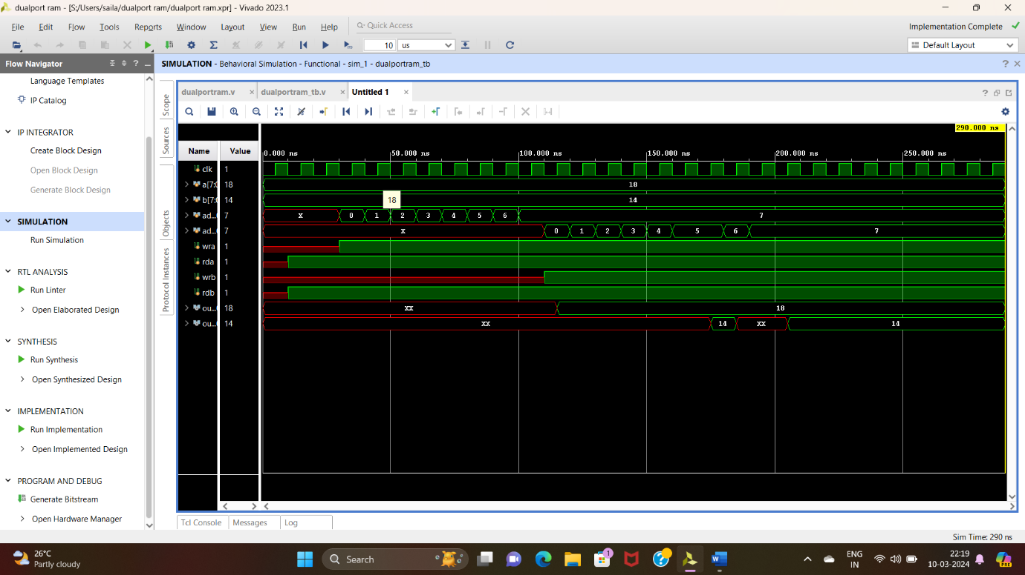

**Schematic Diagram:**

